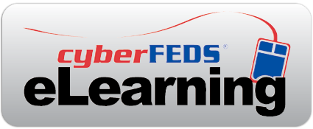

Dear <Insert your Supervisor’s Name>,

Because *cyber*FEDS® has been so valuable to the professional development of our agency staff, I would like approval to purchase the ***cyber*FEDS eLearning** courselibrary for the purposes of providing our staff mandatory and refresher training on core areas and processes involving EEO, employee relations, labor relations, and workers’ comp. As an add-on to our existing *cyber*FEDS subscription, the eLearning library is easily accessible through the site. With 100+ online courses, we can tailor each staff member’s training to address their specific knowledge gaps.

*cyber*FEDS eLearning courses will help expand staff knowledge and build their skills on specific issues related to performance management, disciplinary actions, dispute resolution, accommodations, the EEO process, and more key areas. We would also get access to the No FEAR Act Training course, which satisfies the mandate for training all employees on federal whistleblower and antidiscrimination laws, and also covers the Pregnant Workers’ Fairness Act.

I am seeking approval for the add-on cost, which includes access to the entire eLearning Library for all of the users on our existing *cyber*FEDS subscription:

Add-on cost total: $<insert cost>

You can view information on ***cyber*FEDS eLearning** at [www.cyberFEDS.com/eLearning](http://www.cyberFEDS.com/eLearning). Please consider my request as this library would be an invaluable training resource.

Sincerely,

<Insert your name>